**HTML Lab:**

**Welcome back after vacation!!** ☺

|  |
| --- |
| I hope you would have practiced and explored html while creating you personal website (i.e. assignment 3). However, today’s lab again is on html (with some more attributes that we didn’t discuss as such). P  Purpose of this lab is to let you practice more and provide you this time slot so that you can ask TAs about any html related issues you may have faced.  *We’ll move to JavaScript in next lecture.* |

*We had already discussed how to insert an image.*

**Exercise**

You are given a file named **first.html** that represents a web page. You have to write a style sheet (i.e. CSS file) called layout.css that will transform the layout in different ways throughout the following Tasks.

*Some of the properties needed for this exercise are:*

* *margin-left*
* *margin-right*
* *margin-top*
* *border*
* *border-bottom-style*
* *border-bottom-width*
* *background-image*
* *background-color*
* *padding*
* *text-align*

To help you out, you are also given a file named basic.css that defines some basic styling for this page, and it is already linked for you in the first.html.

**Instructions:**

* Try to make different hmtl page and css file for each task..

**Task1:** Initially the page looks as below:



You have to modify it and layout.css so that the borders are added to different sections as below:

**Hint** : you can add different DIV tags to create different sections.

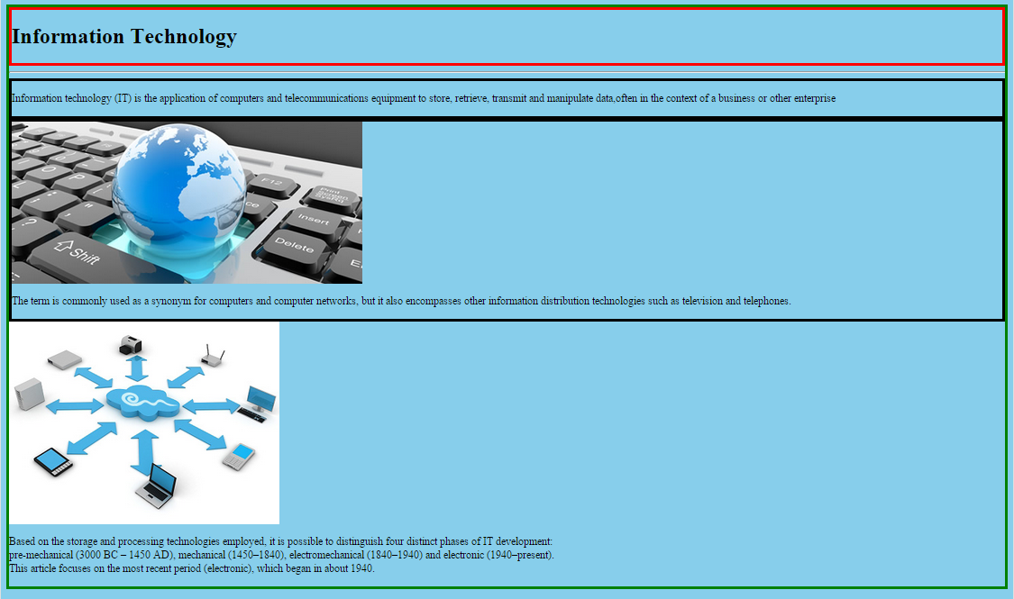

**Task 2:**

2.1. Now again modify the files such that left and right margins are added to page as shown below:

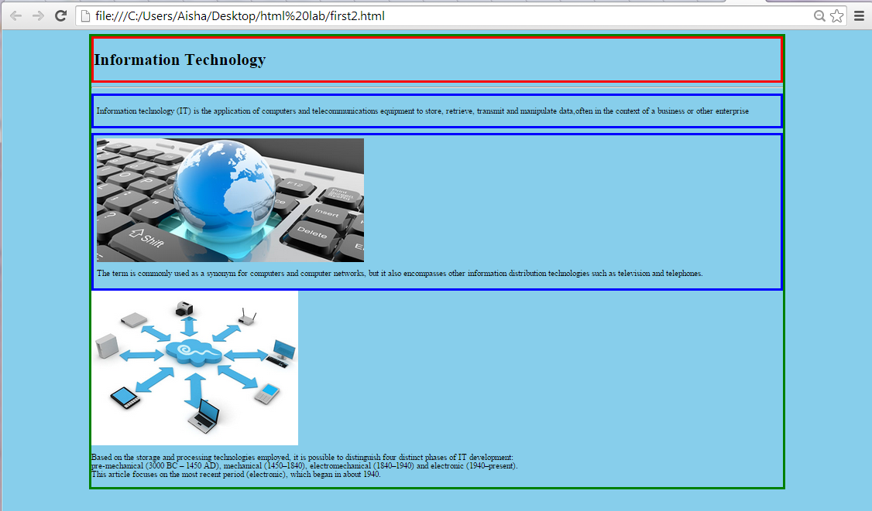

2.2. Put an image (background.jpg) in the background of your page. ( **hint:** css property for this is **background-image**, other properties that will be help full are **background-repeat** and **background-attachment**, explore these properties). Your page should look like:



**Task 3:**

Add some more properties and adjust their value to change layout as below:



Codes of colors used as background for different sections are:

* #E8FBFB
* #C2E9E9
* #A8F0F0

**Hint** color can be set both by color name or color code e.g. you’ll write as **background-color: #E8FBFB;**

**Finally, set the background color or main div to white as well and your page should look like below.**

